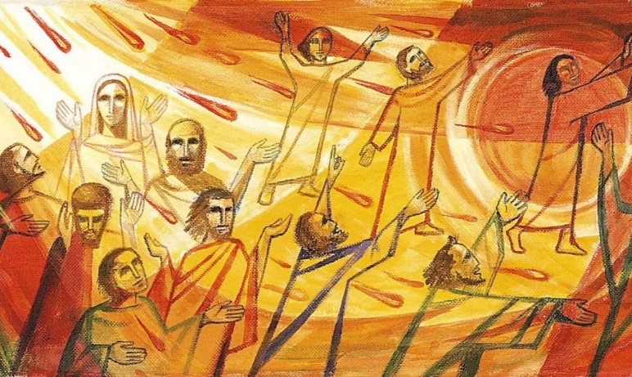
Welcome to worship!

Sunday May 31, 2020

Pentecost

A joint online Zoom worship Service with:

Claremont, Fairbank & Goodwood United Churches plus guests

Leaders: Pastor Steven Loweth & Rev. Lionel Ketola
Onelicense # A-723979 CCLI # 11550809

Announcements & Today’s Worship Theme

Lighting the Christ Candle
There was a man named Jesus, who embodied God’s love and compassion in such surprising ways. And he said: I am the light of the world

Acknowledgement of the Land ,
I acknowledge the traditional custodians of the land we have gathered on today. I pay my respects to the Elders past, present and emerging, for they hold the memories, the traditions, the culture and hopes of all Aboriginal on Turtle Island.
God of justice, help us to embody your call to reconciliation with our First Nations in tangible, loving ways. Amen.

We Gather to in Joyful Celebration

Opening Hymn: Breathe of my Breath of God Video

Call to Worship
The Spirit wind comes
We perceive it is such diverse ways;
A mighty wind that overwhelms
or a calm breeze that comfort;
a movement that refreshes
or a tornado that destroys what we know;

We come on this Pentecost Sunday
To be shaped by this Spirit wind;
a helper that guides
or a challenging gale that pushes us to new places;
a thermal that soars into all possibilities
or a friend that accompanies us with love;
a whirlwind that gathers us together
or a chinook that warms new life.

As we come together, whether challenged
Or comforted we ask that you Light us up, O God,
So that we may burn for the way of Jesus.
Blow on the embers of our faith
That we may blaze light into the world.
Illuminate our lives this morning with
Transformation and with opportunity.
Amen

Prayer of the Day

Holy One,
We thank you for the gift of the Holy Spirit;
Its empowering and enlightening energy
Floods us with your light.
Send your Spirit upon us and your world
So that no matter our gender, our status, our age, our context
We will be filled with your light and love.
Amen.

Word

One: Whether you take what is written in the Bible as fact, metaphor, myth or story, listen now to these words for the meaning they hold in your lives today.
All: May the Spirit bless us with wisdom and wonder, as we ponder the meaning of these words in our lives.
Scripture Readings:

First Reading: Acts 2:1-21
2When the day of Pentecost had come, they were all together in one place. ²And suddenly from heaven there came a sound like the rush of a violent wind, and it filled the entire house where they were sitting. ³Divided tongues, as of fire, appeared among them, and a tongue rested on each of them. ⁴All of them were filled with the Holy Spirit and began to speak in other languages, as the Spirit gave them ability.
⁵Now there were devout Jews from every nation under heaven living in Jerusalem. ⁶And at this sound the crowd gathered and was bewildered, because each one heard them speaking in the native language of each. ⁷Amazed and astonished, they asked, “Are not all these who are speaking Galileans? ⁸And how is it that we hear, each of us, in our own native language? ⁹Parthians, Medes, Elamites, and residents of Mesopotamia, Judea and Cappadocia, Pontus and Asia, ¹⁰Phrygia and Pamphylia, Egypt and the parts of Libya belonging to Cyrene, and visitors from Rome, both Jews and proselytes, ¹¹Cretans and Arabs—in our own languages we hear them speaking about God’s deeds of power.” ¹²All were amazed and perplexed, saying to one another, “What does this mean?” ¹³But others sneered and said, “They are filled with new wine.”
¹⁴But Peter, standing with the eleven, raised his voice and addressed them, “Men of Judea and all who live in Jerusalem, let this be known to you, and listen to what I say. ¹⁵Indeed, these are not drunk, as you suppose, for it is only nine o’clock in the morning. ¹⁶No, this is what was spoken through the prophet Joel: ¹⁷‘In the last days it will be, God declares, that I will pour out my Spirit upon all flesh, and your sons and your daughters shall prophesy, and your young men shall see visions, and your old men shall dream dreams. ¹⁸Even upon my slaves, both men and women, in those days I will pour out my Spirit; and they shall prophesy. ¹⁹And I will show portents in the heaven above and signs on the earth below, blood, and fire, and smoky mist. ²⁰The sun shall be turned to darkness and the moon to blood, before the coming of the Lord’s great and glorious day. ²¹Then everyone who calls on the name of the Lord shall be saved.’
Holy Wisdom Holy Word Thanks be to God
Reflection: Pastor Steven Loweth
Gospel Acclamation: VIDEO

Holy Wisdom, Holy Word Thanks be to God

Holy Gospel of John 20:19-23
¹⁹When it was evening on that day, the first day of the week, and the doors of the house where the disciples had met were locked for fear of the Jews, Jesus came and stood among them and said, “Peace be with you.” ²⁰After he said this, he showed them his hands and his side. Then the disciples rejoiced when they saw the Lord. ²¹Jesus said to them again, “Peace be with you. As the Father has sent me, so I send you.” ²²When he had said this, he breathed on them and said to them, “Receive the Holy Spirit. ²³If you forgive the sins of any, they are forgiven them; if you retain the sins of any, they are retained.”

Reflection: Rev. Lionel Ketola

We Respond to the Joyful News

Hymn of the Day: Spirit of the Living God Video

Invitation to the Offering

Offering Prayer

Bountiful God,
we come with our offerings in response to your love.
With the new life in Christ,
we give ourselves in service to others.
With the energy bestowed by the Spirit,
we seek to inflame all your people with a zeal for your way.
Receive the work we do,
and the gifts we bring,
that they may become a blessing in your sight.

Prayers of the People

God of Pentecost,
In these days of knowing, and not knowing,
We are like the buds on the trees,
eager to burst forth into the world.
Please hold us gently in place
until we are certain in the ways of loving our neighbor.

Let us not toss ourselves and others into thoughtless harm.
Let us recall that all life is sacred in your eyes,
not only that of the unborn child,
but also those with lines of life lived etched upon their hands and faces,
and including those whose immune systems are compromised.
These, too, are your beloved, whose care we are blessed to bear.
We pray for all those in long term care homes.

God in Your Mercy, Hear our Prayer

We seek blessing upon those
who have answered a call to care for us.
We pray for all front line workers.

God in Your Mercy, Hear our Prayer

Help us to hear that caring for one another
is your command on our lives.
Open our ears to hear the tragedy in this time of coronavirus,
Open our eyes to see the world as it is today,
Open our hearts so that we can continue loving and helping
Those in need.

God in Your Mercy, Hear our Prayer

Help us to think of what kindness, however small,
we might offer someone.
Help us to remember that our life is not our own,
but belongs to you.
Help us always, Lord, to remember our promise to you
that we will care for our neighbor as ourselves.
Help us to remember all those on our hearts and minds on this day……..

We lift a up these and all our prayers to you we pray as you taught us: Our Mother and Father…
Closing Hymn: Spirit, Open My Heart Video

Blessing and Commissioning

As we leave this time of worship
And while much of the road ahead is uncertain,
We remember Jesus’ words:
“I will not leave you orphaned”
“You will be clothed with power from on high”
“You will be my witnesses”
And as we go forth to live out our calling, may the blessing of God,
Creator, Christ and Holy Spirit, fill us with peace and with power, now and always. Amen!

Sung Blessing: We Are Not Alone VIDEO

ANNOUNCEMENTS

Goodwood United Church: Online Check-in: Tuesdays at noon, on Zoom. Once our check in time has come to a conclusion, the group will proceed with our weekly Bible Study / “Conversations about Life”, so feel free to join us for this as well.

Claremont United Church: Wednesdays @ 12:00 noon - Join us for a Zoom drop in meeting Everyone is invited to join us for these “virtual Brock Café” gatherings to connect with each other and check in with our congregational community.

Check out our websites! Both Goodwood United Church and Claremont United Church websites are updated with new material, so check them out!
Continued Support for our Congregations
Please prayerfully consider how you can continue to support your congregation’s ongoing ministries during this time.
- Offerings can be mailed to the church address itself
- PAR forms (for pre-authorized debit) are available from your church treasurer
- You can send your offering by E-TRANSFER through your bank.
For e-transfers to Claremont United, sent it to: treasurercuc@outlook.com
For e-transfers to Goodwood United, send it to: goodwooductreasurer@gmail.com

Thank you for your continued support of our congregation’s ministry.

Find us online! Check out our websites!
Check out our church websites for new updates during this time, including Sunday devotions,
and also information about coping with stress during the COVID-19 pandemic.

www.claremontunitedchurch.com
www.goodwoodunitedchurch.com

Find us on Facebook!

https://www.facebook.com/goodwoodunited
https://www.facebook.com/claremontunited

