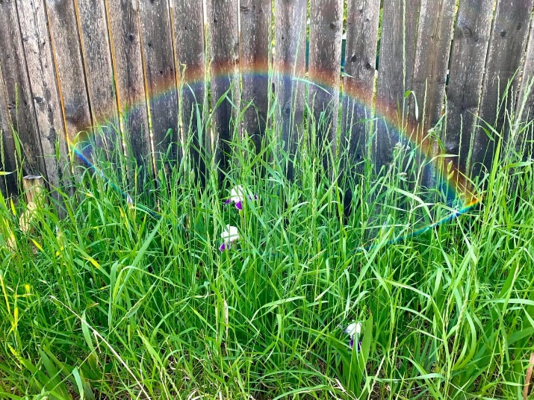
Welcome
to worship!

Sunday June 28, 2020

3nd Sunday

after Pentecost

Pride Sunday

A joint online Zoom worship Service with: Claremont, Fairbank & Goodwood United Churches and Guests

Leaders: Pastor Steven Loweth & Rev. Lionel Ketola
Onelicense # A-723979 CCLI # 11550809

Announcements & Today’s Worship Theme

We Gather to in Joyful Celebration

Lighting the Christ Candle
There was a man named Jesus, who embodied God’s love and compassion in such surprising ways. And he said: I am the light of the world

Acknowledgement of the Land
As we begin our worship, we acknowledge the traditional custodians of the land where each of us are gathered today. We pay my respects to the Elders past, present and emerging, for they hold the memories, the traditions, the culture and the hopes of all Indigenous peoples on Turtle Island.

God of justice, help us to embody your call to reconciliation with our First Nations in tangible, loving ways. Amen.

Opening Hymn: Love Divine All Loves Excelling VIDEO

Call to Worship
One: All you who delight in Diversity; all you who seek the Holy in the presence of the Stranger, come and worship the queer Creator who is Holy Mystery and Wholly Love.
All: Thanks be to God who blesses the peculiar, who turns our understanding of ‘normal’ upside down, who rejoices in the uniqueness of every body, every being, and every expression of life.

The Holy takes on flesh in every gender and sexual orientation, in every culture and ethnicity; in every ability, in every body size and body type.
Each embodied difference is a unique glimpse of Holy Wonder.

Blessed are those who discover God in lives of the oppressed, the betrayed, the turned-away, and the condemned.
Blessed are those who receive with joy the gifts of God enfleshed among us.
The Sacred is with us. Let us worship and be transformed.

Prayer of the Day
God, when you called each of us into being, you delighted in your works. You gifted us with differences that illuminate the breadth of beauty, wisdom, and practices of love in your creation. In whatever ways we still struggle to accept and celebrate our own unique offerings, free us from narrow thinking that confines, constrains, or condemns your good work in us. Amen.

We Open our Hearts to the Spirit’s Voice

One: Whether you take what is written in the Bible as fact, metaphor, myth or story, listen now to these words for the meaning they hold in your lives today.
All: May the Spirit bless us with wisdom and wonder, as we ponder the meaning of these words in our lives.

Genesis 1: 26 – 28a, 29-31
²⁶Then God said, “Let us make humankind in our image, according to our likeness; and let them have dominion over the fish of the sea, and over the birds of the air, and over the cattle, and over all the wild animals of the earth, and over every creeping thing that creeps upon the earth.” ²⁷So God created humankind in his image, in the image of God he created them; male and female he created them. ²⁸God blessed them.
²⁹God said, “See, I have given you every plant yielding seed that is upon the face of all the earth, and every tree with seed in its fruit; you shall have them for food. ³⁰And to every beast of the earth, and to every bird of the air, and to everything that creeps on the earth, everything that has the breath of life, I have given every green plant for food.” And it was so.
³¹God saw everything that he had made, and indeed, it was very good. And there was evening and there was morning, the sixth day.

Scripture Song: Spirit of Life VIDEO

Matthew 10: 40–42
⁴⁰“Whoever welcomes you welcomes me, and whoever welcomes me welcomes the one who sent me. ⁴¹Whoever welcomes a prophet in the name of a prophet will receive a prophet’s reward; and whoever welcomes a righteous person in the name of a righteous person will receive the reward of the righteous; ⁴²and whoever gives even a cup of cold water to one of these little ones in the name of a disciple—truly I tell you, none of these will lose their reward.”

Holy Wisdom, Holy Word Thanks be to God

Sermon Rev. Lionel

We Josyfully Respond to the Good News

Hymn of the Day: My Love Colours Outside the Lines MV # 120 VIDEO

Invitation to the Offering
Since its beginning, the church was meant to be a place of chosen family—a community of outcasts and outlaws, dreamers, prophets, and humble disciples of Love. In the company of Divine Presence, we create belonging and nurture justice. With gratitude for the sacred labours of love in this place, let us bring our offerings to God and one another.

Prayer of Dedication for the Gifts
Beloved One, we offer our thanks for the holy witness in the lives of LGBTQIA+ and Two-Spirited people. In queer love and in trans and intersex bodies, we experience Christ enfleshed. In the faith of those who have been persecuted by the church, Christ is revealed. In the queer practices of community, of love that takes risks, and of telling the truth—even when it’s costly—Christ lives on. In gratitude for these and all the sacred gifts of the LGBTQIA+ and Two-Spirit community, we give our thanks and offer these gifts. Amen.
Prayers of the People
A Pride Day Prayer: For The Great Diversity You Have Created” - by Ruth Wood

Creator, we come to you with both the joys and the sorrows of our hearts.
We are grateful for the gift of life and the joy that it can bring.
For families and friends who love us.
For allies who stick up for us,
even when we cannot risk sticking up for ourselves.
For the great diversity you have created in our world.
We pray for those who suffer from discrimination
because of their gender identity or sexual orientation.
Who worry about their employment or who cannot find a job.
For those who must hide who they are to find housing.
For those who are not safe on our streets.
For those who do not feel safe in their place of worship.
Help us to end homophobia, transphobia, and biphobia,
and all forms of discrimination and hate.
Show us the way to make this world a better place for all.

God in your love, hear our prayer.
Tender God, we now lift up to you all whose needs are close to our hearts this day …

Into your hands, Tender God, we commend all for whom we pray, trusting in your great love for us. All this we ask in Jesus’ name, who showed us your Mothering love and who taught us to pray: God, our Mother and Father in heaven, hallowed be thy name ... Amen.

Closing Hymn: We are a Rainbow by David Kai VIDEO
We’re the light of all the world, we are a city on a hill,
We’re a candle on a stand proclaiming light,
We will not hide our lamp beneath a bushel any more,
We will shine a ray of hope that’s burning bright.
Chorus: We are a rainbow, sign of covenant and peace,
For the flood of tears will finally cease to be,
Come shine your rainbow, splash your hues across the sky,
Paint the world in colours proud and bold and free.

We’re a coat of many colours, sewn from many different threads,
Covering all in warmth, in welcome and in grace,
God said “Let there be light”, created every varied shade,
In the rainbow each of us can find a place. Chorus

We are hope to still believe in tomorrow’s better day,
We are peace in a world that’s torn apart,
We are joy that will last in all the struggles that we face,
We are love that blooms and grows in every heart. Chorus

When we face the storms of life, we will never be alone,
For our God will be with us on the way,
Hand in hand, side by side, we won’t be frightened*
any more, As the mourning night of tears breaks into day. Chorus

Blessing and Commissioning
Let us go from here to proclaim the good news:
God takes on flesh in the strange and surprising.
Love liberates from the margins.
Together, we have what we need to resist evil and oppression.

With a renewed commitment to solidarity with God and all LGBTQIA+ and Two-Spirit people, may the Spirit lead us from this place with peace.
Amen

Dismissal: “For the Great Diversity You Have Created” VIDEO

Next Sunday’s Readings:

July 5 – Fifth after Pentecost / Proper 9
Genesis 24:34–38, 42–49, 58–67 Rebekah is found as a wife for Isaac.
Psalm 45:10–17 (VU p. 769) A song for the anointed ruler.
or Song of Solomon 2:8–13 A love song.
Romans 7:15–25a I do not do the good I want to do.
Matthew 11:16–19, 25–30 My yoke is easy; my burden is light.

ANNOUNCEMENTS

Online Zoom Book Study Group (Claremont & Goodood United): Our weekly book study starts Friday June 19th at 10:00 am and will happen every Friday morning at 10 AM until the end of July. We will study Rev. Lenny Duncan’s book: “Dear Church: A Love Letter from a Black Preacher to the Whitest Denomination in the U.S.” which addresses the theme of anti-racism.
Get your copy online and read along with us and join us for our Zoom conversations. The meetings will be approx an hour and a half. On Friday July 3rd we will be discussing chapters 5 & 6.

Goodwood United Church: Online Check-in: Tuesdays at noon, on Zoom. Once our check in time has come to a conclusion, the group will proceed with our weekly Bible Study / “Conversations about Life”, so feel free to join us for this as well.

Claremont United Church: Wednesdays @ 12:00 noon - Join us for a Zoom drop in meeting Everyone is invited to join us for these “virtual Brock Café” gatherings to connect with each other and check in with our congregational community.

Continued Support for our Congregations
Please prayerfully consider how you can continue to support your congregation’s ongoing ministries during this time.
- Offerings can be mailed to the church address itself
- PAR forms (for pre-authorized debit) are available from your church treasurer
- You can send your offering by E-TRANSFER through your bank. next page.
For e-transfers to Claremont United, sent it to: treasurercuc@outlook.com
For e-transfers to Goodwood United, send it to: goodwooductreasurer@gmail.com
Thank you for your continued support of our congregation’s ministry.

Find us online! Check out our websites!
Check out our church websites for new updates during this time, including Sunday devotions, and information about coping with stress during COVID-19.

www.claremontunitedchurch.com
www.goodwoodunitedchurch.com
Find us on Facebook!

https://www.facebook.com/goodwoodunited
https://www.facebook.com/claremontunited

