Welcome to worship!

Sunday June 21, 2020

3nd Sunday after Pentecost

“Earth Communion”

A joint online Zoom worship Service with:

Claremont, Fairbank & Goodwood United Churches

and Guests

Leaders: Pastor Steven Loweth & Rev. Lionel Ketola
Onelicense # A-723979 CCLI # 11550809

Announcements & Today’s Worship Theme

We Gather to in Joyful Celebration

Lighting the Christ Candle
There was a man named Jesus, who embodied God’s love and compassion in such surprising ways. And he said: I am the light of the world

Acknowledgement of the Land
As we begin our worship, we acknowledge the traditional custodians of the land where each of us are gathered today. We pay my respects to the Elders past, present and emerging, for they hold the memories, the traditions, the culture and the hopes of all Indigenous peoples on Turtle Island.
God of justice, help us to embody your call to reconciliation with our First Nations in tangible, loving ways. Amen.

Opening Hymn: All Creatures of our Lord and King VIDEO

- All creatures of our God and King,
Lift up your voice and with us sing,
Alleluia! Alleluia!
Thou burning sun with golden beam,
Thou silver moon with softer gleam!
Refrain:
O praise Him! O praise Him!
Alleluia! Alleluia! Alleluia!
- Thou rushing wind that art so strong,
Ye clouds that sail in heav’n along,
O praise Him! Alleluia!
Thou rising moon, in praise rejoice,
Ye lights of evening, find a voice!
- Let all things their Creator bless,
And worship Him in humbleness,
O praise Him! Alleluia!
Praise, praise the Father, praise the Son,
And praise the Spirit, Three in One!

Call to Worship written by Katherine Hawker

Grace and peace to you from God our Father,
who has blessed us with every spiritual blessing
that comes from heaven: (Eph 1)
who knew you and chose you before the world began; (I Pet 1, Eph 1)
who loves you so much that he calls you his own children; (I Jn 3)
who has filled you with his glorious power; (Col 1)
who has prepared an inheritance for you
that will never spoil or fade; (I Pet 1)
who encourages and strengthens you
in every good deed and word; (2 Thess 2)
who comforts you in your troubles
so that you can comfort others. (2 Cor 1)
This is our God,
the ultimate source of all things,
and the One for whom we live. (I Cor 8)
Come Let us worship God together!

Prayer of the Day
God of small seeds and mighty plants, you take our meager lives and with your love cause them to produce acts of loving kindness for you in this world. You hear our cries and find us when we are lost and wandering in fear. You bring us home with you so that we may be made whole, rejoicing in your goodness. Help us to joyfully serve you all our days, knowing that you are always watching over us. Prepare our hearts to receive your word and our spirits to respond in eagerness to serve you. In Jesus’ name, we pray. Amen.

We Open our Hearts to the Spirit’s Voice

One: Whether you take what is written in the Bible as fact, metaphor, myth or story, listen now to these words for the meaning they hold in your lives today.
All: May the Spirit bless us with wisdom and wonder, as we ponder the meaning of these words in our lives.

Reflection on Re-Opening Church: Pastor Steven Loweth

Scripture Readings:

A reading from the Prophet Isaiah (24: 4-6)

⁴The earth dries up and withers, the world languishes and withers; the heavens languish together with the earth. ⁵The earth lies polluted under its inhabitants; for they have transgressed laws, violated the statutes, broken the everlasting covenant. ⁶Therefore a curse devours the earth, and its inhabitants suffer for their guilt; therefore the inhabitants of the earth dwindled, and few people are left.

Scripture Song: Spirit of Life VIDEO

The Holy Gospel According to Mark (4:26-34)
²⁶Jesus also said, “The kingdom of God is as if someone would scatter seed on the ground, ²⁷and would sleep and rise night and day, and the seed would sprout and grow, but he does not know how. ²⁸The earth produces of itself, first the stalk, then the head, then the full grain in the head. ²⁹But when the grain is ripe, at once he goes in with his sickle, because the harvest has come.”

Holy Wisdom, Holy Word Thanks be to God

Sermon Rev. Lionel

We Respond to the Joyful News

Hymn of the Day: Touch the Earth Lightly VIDEO

Prayers of the People
Gracious and loving God,
Psalm 46 reminds us that,
‘You are our refuge and strength, an ever-present help in trouble.’

God, we feel deeply that our world is in trouble
with the spread of Covid-19.
There continues to be a heightened sense of fear and anxiety about the future.

We ask that we may calmly and lovingly trust in you
and care for all who are affected by this pandemic.
Please bless the work of health professionals,
government officials, aged care providers, school and community leaders.
Grant them strength and wisdom.

We pray for all who feel stressed and worried,
that they might find peace and reassurance.
Free us from panic and selfish stockpiling.

We pray for all those who mourn the loss of loved ones to the virus,
that they will find comfort and support.

May all our congregations and faith communities
be places of empathy, compassion and calm in all we face.

God in your Mercy, Hear our prayer

Tender God, we now lift up to you all whose needs are close to our hearts this day …

Into your hands, Tender God, we commend all for whom we pray, trusting in your great love for us. All this we ask in Jesus’ name. Amen.

Invitation to the Offering

Offering Prayer
Awesome God, What mysteries there are in your world!
We stand in awe at the wonders of the nature.
We look at the tiniest of seeds and wonder what will happen.
From that small seed a large shrub will grow.
Although we consider our gifts to be small and insignificant,
We ask that You use our gifts in miraculous ways.
We pray in this the name of the one who teaches us to love. Amen.

Holy Communion

Adapted from a liturgy from the Uniting Church of Australia

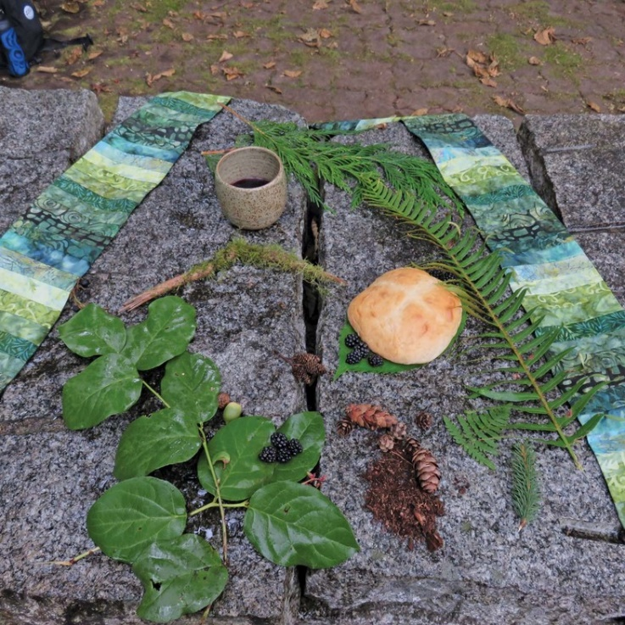
May God be with you
And also with you!
Lift up your hearts
We lift them up in joyful song!
Let us give thanks to our God
It is right to offer our songs of praise!

God of Life,
we praise you for your great love -
the impulse which calls all life into being:
Stars and stardust,
galaxies and universes;
planet earth, and the web of creation.

You chose to be born a child of the Earth,
to know our joys and vulnerability;
to suffer, die and rise from death
so that all creation might know abundant life.

Your presence is the living impulse in all things,
the Christ deep among us,
filling Earth —land, sea and air;
filling every element of creation;
filling the bread and wine that we share with you this day.

Therefore with angels and archangels,
with ancient voices in the forest,
high voices from the sky,
deep voices from the sea
and the whole company of creation,
we join in their joyful song of praise: VIDEO: For the Beauty of the Earth

For the beauty of the earth
for the glory of the skies
for the love which from our birth
over and around us lies,
God of all to you we raise
this our hymn of grateful praise.
We give thanks for Jesus, who on the night before his unjust death, took bread, gave thanks, broke it, and gave it to his friends, saying “Take and eat. This is my body, the bread of the Earth, which is given for you. Do this in remembrance of me”
After supper Jesus took the cup, saying: “Take and drink, this is the cup of the new covenant with all creation - the life-blood of all creation - poured out for all people. Do this in remembrance of me.”

Loving One, with this bread and cup, we rejoice and proclaim the mystery of our faith:
Christ has died. Christ is risen. Christ will come again.

Tender God, send your life-giving Spirit upon us and upon these gifts of the earth - this bread and cup.
Give us grace to share our bread with the hungry and with the hungry of heart.
Draw us into your dance of life - and into your vision of Creation made new!

With Jesus, and the whole web of creation, we pray together:
“God our Mother and Father in Heaven, hallowed be thy name …”

At the breaking of the bread
The gifts of the earth for the people of the earth!
Thanks be to God!

Post-Communion Prayer
Nourishing God,
you feed us with your abundant life at Creation’s table.
Send us out with joy
to be loving partners with the Sacred Web of Life.
We pray this in Jesus’ name. Amen.

Closing Hymn: How Great Thou Art

Blessing and Commissioning

May you see the beauty of God in sun and sky;
my you hear the Creator’s song in bird and breeze;
and may the grace of Christ’s Spirit course through you – body, mind and soul.
Amen.

Sung Dismissal: I am Walking a Path of Peace VIDEO

Next Sunday’s Readings: June 28 – Fourth after Pentecost / Proper 8

Genesis 22:1–14
The sacrifice of Isaac.

Psalm 13 (VU p. 734)
How long will you forget me, God?

Romans 6:12–23
The wages of sin is death; eternal life is a free gift.

Matthew 10:40–42
Welcoming and offering a cup of water.

ANNOUNCEMENTS

Online Zoom Book Study Group (Claremont & Goodood United): Our weekly book study starts Friday June 19th at 10:00 am and will happen every Friday morning at 10 AM until the end of July. We will study Rev. Lenny Duncan’s book: “Dear Church: A Love Letter from a Black Preacher to the Whitest Denomination in the U.S.” which addresses the theme of anti-racism.
Get your copy online and read along with us and join us for our Zoom conversations. The meetings will be approx an hour and a half. On Friday June 26 we will be discussing chapters 3 & 4.

Goodwood United Church’s Virtual Lunch Fundraiser – Thursday June 25. Enjoy making a light summertime lunch at home, and make a donation to the Uxbridge Loaves and Fishes Food Bank. To send your photo & a description of your lunch to our Goodwood United Church’s Facebook page, simply find Rev. Lionel’s post for our Virtual Lunch on our Facebook page, and write a comment with a photo attachment to Rev. Lionel’s post.

Goodwood United Church: Online Check-in: Tuesdays at noon, on Zoom. Once our check in time has come to a conclusion, the group will proceed with our weekly Bible Study / “Conversations about Life”, so feel free to join us for this as well.

Claremont United Church: Wednesdays @ 12:00 noon - Join us for a Zoom drop in meeting Everyone is invited to join us for these “virtual Brock Café” gatherings to connect with each other and check in with our congregational community.

Check out our websites! Both Goodwood United Church and Claremont United Church websites are updated with new material, so check them out!
Continued Support for our Congregations
Please prayerfully consider how you can continue to support your congregation’s ongoing ministries during this time.
- Offerings can be mailed to the church address itself
- PAR forms (for pre-authorized debit) are available from your church treasurer
- You can send your offering by E-TRANSFER through your bank. next page.
For e-transfers to Claremont United, sent it to: treasurercuc@outlook.com
For e-transfers to Goodwood United, send it to: goodwooductreasurer@gmail.com
Thank you for your continued support of our congregation’s ministry.

Find us online! Check out our websites!
Check out our church websites for new updates during this time, including Sunday devotions,
and also information about coping with stress during the COVID-19 pandemic.

www.claremontunitedchurch.com
www.goodwoodunitedchurch.com

Find us on Facebook!

https://www.facebook.com/goodwoodunited
https://www.facebook.com/claremontunited

